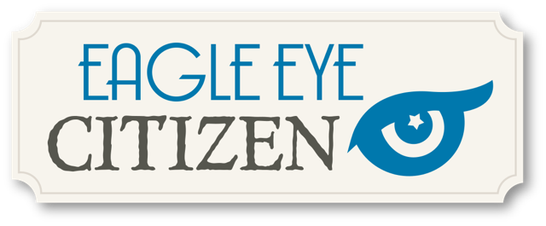

Solving a Challenge Rubric
 | Excellent | Good | Fair | Poor
Observe  What did you notice first? What did you see when you looked closely at each source? | Student response is thoughtful and demonstrates high level analysis of primary source(s) and critical thinking skills. | Student response is thoughtful and demonstrates analysis of primary source(s) and some critical thinking skills. | Student response demonstrates some engagement with primary source(s). | Student response demonstrates little or no engagement with primary source(s).
Question  What else do you want to know? | Student response demonstrates engagement with the overall challenge and presents insightful topics and questions to investigate further. | Student response demonstrates some engagement with the overall challenge and presents topics and questions to investigate further. | Student response somewhat demonstrates engagement with the overall challenge but may not present new inquiries. | Student response demonstrates little or no engagement with the overall challenge and does not present new inquiries.
Reflection  What did you learn? | Student response demonstrates clear understanding of the challenge material and/or new insights into the topic. | Student response demonstrates some understanding of the challenge material and/or new insights into the topic. | Student response demonstrates basic understanding of the challenge material. | Student response demonstrates little or no understanding of the challenge material.

